Individual Project 2
Olivia Harper
2025-12-06
NOTE: Figure/image size reduced to reduce the number of pages.
Research Hypothesis: Do location characteristics (city,crime cases, legal reports) impact house price in the UK?
Data: Global House Purchase Decision Dataset Variables: Response: Price Explanatory: Crime Cases Reported, Legal Cases on Property
Crime Cases Reported: Crime reports near property Legal Cases on Property: Legal disputes (yes, no) Interaction: City (Birmingham (0), Liverpool (1), London (2), Manchester(3))
Idea: St up exploratory plots of the variables used. Fit a model with the above variables. Run diagnostics on them to check for linearity, normality, outliers,non-constant variance, and multicollinearity. Perform any remedial methods beforecreating the final model and test.
Notes: Steps 1 - 12 pertain to my individual model. Steps 13 - 19 pertain to analysis on the full model not including initial fit and model selection.
STEP 1: INSTALLING PACKAGES AND LIBRARIES
install.packages("lmtest", repos = "https://cran.rstudio.com/")
##
## The downloaded binary packages are in
## /var/folders/8j/8fpm50yx6cscb6j9n72jklpw0000gn/T//RtmpiX88RQ/downloaded_packages
library(dplyr)
library(tidyr)
library(car)
library(ggplot2)
library(lmtest)
library(MASS)
library(glmnet)
STEP 2: IMPORTING THE DATASET AND SUBSETTING DATASET
data <- read.csv("~/STAT512/global_house_purchase_dataset.csv")
data_uk <- data |>
filter(country == "UK") #creating a new dataset for rows only pertaining to the UK
df <- data_uk[0:500,] #Taking the first 500 samples, becuase the dataset is over 15000
STEP 3: DESCRIPTIVE STATISTICS, EXPLORATORY PLOTS, EARLY PATTERNS AND CONCERN
Summary: Price shows a highly uniform histogram, but was one of the few continuous variables to choose from. Crime ended up being more categorical with the highest number reported being 4. Legal cases is binary, about 3:1 ratio (0:1)
#PRICE
summary(df$price) #Preliminary look at the variable trends (summary for continuous)
## Min. 1st Qu. Median Mean 3rd Qu. Max.
## 157747 705308 1280110 1271588 1839657 2398384
#Histogram of Price
hist(df$price,
main = "Histogram of UK House Prices",
xlab = "Price",
ylab = "Frequency",
border = "black")
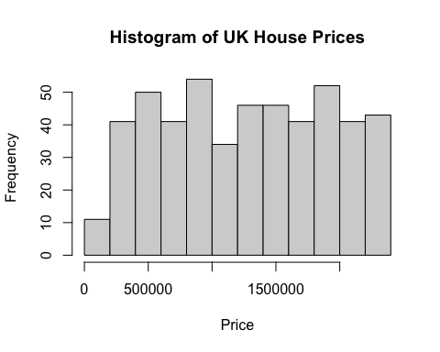 #CRIME CASES REPORTED
summary(df$crime_cases_reported) #Prelim look at the variable trends
## Min. 1st Qu. Median Mean 3rd Qu. Max.
## 0.00 0.00 1.00 0.93 1.00 4.00
#Histogram of Crime Cases Reported
hist(df$crime_cases_reported,
main = "Histogram of UK Crime Cases Reported",
xlab = "Crime Cases Reported",
ylab = "Frequency",
border = "black")
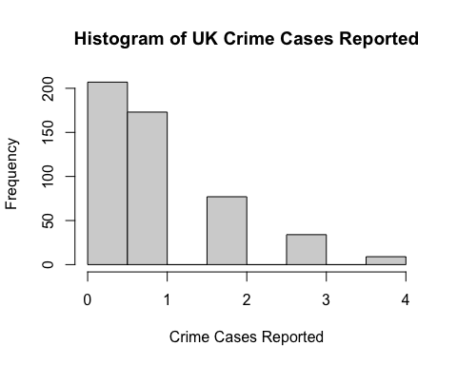
#Scatterplot: Price vs. Crime Cases Reported
ggplot(df, aes(x = crime_cases_reported, y = price)) +
geom_point() +
geom_smooth(method = "lm", se = FALSE) +
labs(title = "Price vs. Crime Cases Reported",
x = "X",
y = "Y") +
theme_classic()
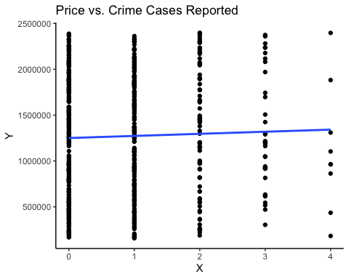 #LEGAL CASES REPORTED ON PROPERTY
table(df$legal_cases_on_property) #Prelim look at trends (table for categorical)
##
## 0 1
## 376 124
#Histogram of Legal Cases
hist(df$legal_cases_on_property,
main = "Histogram of UK Legal Cases on Property",
xlab = "Legal Cases",
ylab = "Frequency",
border = "black")
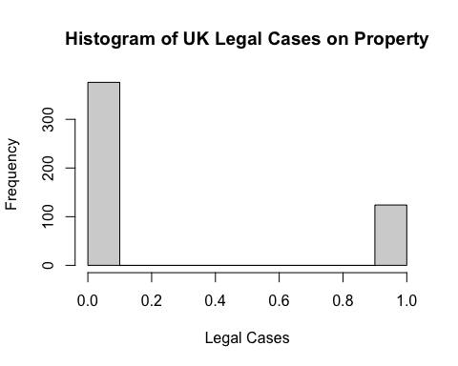
#Scatterplot: Price vs. Legal Cases on Property
ggplot(df, aes(x = legal_cases_on_property, y = price)) +
geom_point() +
geom_smooth(method = "lm", se = FALSE) +
labs(title = "Price vs. Legal Cases on Property",
x = "X",
y = "Y") +
theme_classic()
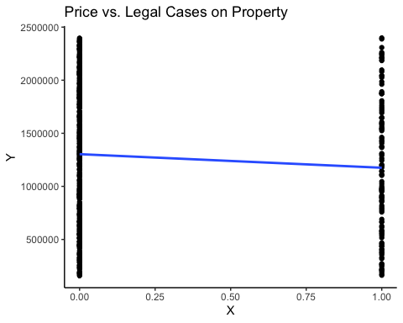 STEP 4: FIT INITIAL MODEL The initial model only shows the intercept as being significant, which is to be expected considering the cities themselves are very similar. Crime and Legal cases have concerning VIF values, but the interaction terms show severe multicollinearity, also likely for the above reason.
base_fit <- lm(price ~ crime_cases_reported + legal_cases_on_property + crime_cases_reported * factor(city) + legal_cases_on_property*factor(city), data = df) #Fitting base model with city as the interaction term
summary(base_fit)
##
## Call:
## lm(formula = price ~ crime_cases_reported + legal_cases_on_property +
## crime_cases_reported * factor(city) + legal_cases_on_property *
## factor(city), data = df)
##
## Residuals:
## Min 1Q Median 3Q Max
## -1163549 -544108 10393 542681 1234916
##
## Coefficients:
## Estimate Std. Error t value
## (Intercept) 1360609 97409 13.968
## crime_cases_reported 83429 67644 1.233
## legal_cases_on_property -288764 147748 -1.954
## factor(city)Liverpool -77334 128228 -0.603
## factor(city)London -45750 126793 -0.361
## factor(city)Manchester -189024 126504 -1.494
## crime_cases_reported:factor(city)Liverpool -62499 88526 -0.706
## crime_cases_reported:factor(city)London -118456 84789 -1.397
## crime_cases_reported:factor(city)Manchester -37596 89279 -0.421
## legal_cases_on_property:factor(city)Liverpool 32403 197352 0.164
## legal_cases_on_property:factor(city)London 275103 203440 1.352
## legal_cases_on_property:factor(city)Manchester 311618 190781 1.633
## Pr(>|t|)
## (Intercept) <2e-16 ***
## crime_cases_reported 0.2180
## legal_cases_on_property 0.0512 .
## factor(city)Liverpool 0.5467
## factor(city)London 0.7184
## factor(city)Manchester 0.1358
## crime_cases_reported:factor(city)Liverpool 0.4805
## crime_cases_reported:factor(city)London 0.1630
## crime_cases_reported:factor(city)Manchester 0.6739
## legal_cases_on_property:factor(city)Liverpool 0.8697
## legal_cases_on_property:factor(city)London 0.1769
## legal_cases_on_property:factor(city)Manchester 0.1030
## ---
## Signif. codes: 0 '***' 0.001 '**' 0.01 '*' 0.05 '.' 0.1 ' ' 1
##
## Residual standard error: 641800 on 488 degrees of freedom
## Multiple R-squared: 0.02963, Adjusted R-squared: 0.007752
## F-statistic: 1.354 on 11 and 488 DF, p-value: 0.1913
#Check for multicollinearity
vif(base_fit) #concerning and severe multicollinearity
## GVIF Df GVIF^(1/(2*Df))
## crime_cases_reported 5.537734 1 2.353239
## legal_cases_on_property 4.941376 1 2.222920
## factor(city) 10.761172 3 1.485856
## crime_cases_reported:factor(city) 22.454032 3 1.679638
## legal_cases_on_property:factor(city) 9.456193 3 1.454184
STEP 5: MODEL DIAGNOSTICS Summary: The QQ-Plot shows pretty significant deviation in the tails and potential outliers, but is relatively symmetrical. The scatterplot of residuals vs. fitted looks different since our two variables are categorical. No obvious curvature. Potential heteroscedasticity, but the Breusch- Pagan test has a non-significant p-value, so the cone shape is due to how the individual variables are distributed (see step 2). The histogram doesn’t look skewed, but also doesn’t look normal (similar structure to the price histogram), and our Shapiro test has a significant p-value so we do have a normality issue.
res_base <- resid(base_fit)
fitted_base <- fitted(base_fit)
#Residual QQ Plot
qqnorm(res_base, main = "Normal Q-Q Plot", xlab = "Residuals", ylab = "Sample Quantiles")
qqline(res_base, col = "blue", lwd = 2)
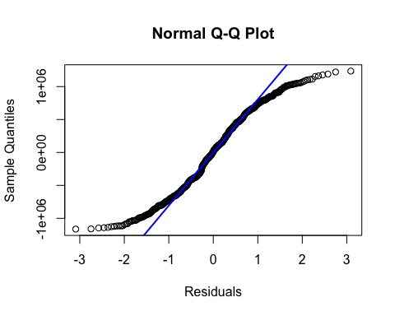
#Residual Plot
plot(fitted_base, res_base)
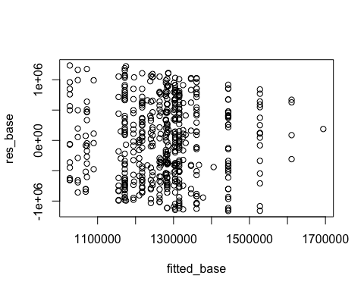
#Histogram of Residuals (to check for normality, heteroscedasticity, non-linearity, and outliers)
hist(res_base,
main = "Histogram of Residuals",
xlab = "Residuals",
ylab = "Frequency",
border = "black"
)
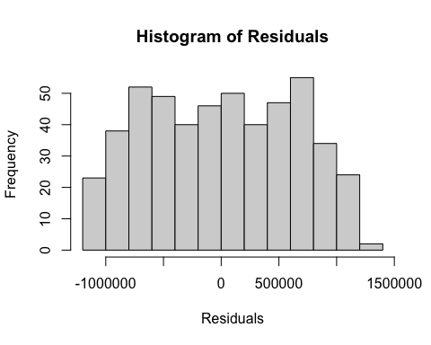
shapiro.test(res_base) #Significant - non-normal
##
## Shapiro-Wilk normality test
##
## data: res_base
## W = 0.96309, p-value = 6.996e-10
bptest(base_fit) #Not significant - has constant variance
##
## studentized Breusch-Pagan test
##
## data: base_fit
## BP = 6.361, df = 11, p-value = 0.8482
STEP 6: CHECK FOR OUTLIERS Since we had a normality issue we want to check for influential points and potential outliers. The influence plot flags 5 values as possible influential points. And theleverage plot show multiple potential outliers as well as multiple based ont he Cook’s D cut value. Based on that we will try removing outliers to see how that will effect the model.
n <- nobs(base_fit)
p <- length(coef(base_fit)) # includes the intercept
lev <- hatvalues(base_fit) #Leverage
D <- cooks.distance(base_fit) #Cook's Distance
rstud <- rstudent(base_fit) #Student's Residuals
cook_cut <- 4/n #Leverage cut-off value
lev_cut <- 2*p/n #Cook cut-off value
mean_lev <- mean(lev)
plot_outliers <- lev[lev > 2 * mean_lev]
influencePlot(base_fit,
scale = 1,
fill = FALSE,
#col = c("black", "red"),
id.method = "noteworthy",
grid = TRUE,
main = "Influence Plot")
## StudRes Hat CookD
## 48 1.9795281 0.06991805 0.024401730
## 118 1.9691803 0.03966920 0.013269935
## 155 -1.5474031 0.09671996 0.021304933
## 411 0.3099593 0.11297865 0.001021635
## 420 -0.7475220 0.15950086 0.008844744
abline(v = lev_cut, lty = 2)
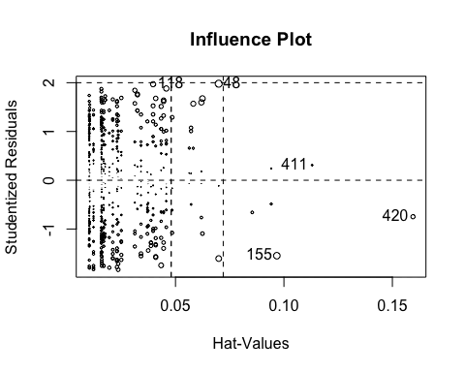
dev.off #Influence plot flags 5 points
## function (which = dev.cur())
## {
## if (which == 1)
## stop("cannot shut down device 1 (the null device)")
## .External(C_devoff, as.integer(which))
## dev.cur()
## }
## <bytecode: 0x7fedac3e1838>
## <environment: namespace:grDevices>
#Summary of Potential Influential Points
summary_influence <- data.frame(
id = seq_len(n),
fitted = fitted(base_fit),
rstud = rstud,
leverage = lev,
cooksD = D,
flag_cook = D > cook_cut,
flag_lev = lev > lev_cut,
flag_big_resid = abs(rstud) > 3
)
#Points to inspect
head(summary_influence[ order(-summary_influence$cooksD), ], 10) #First 10 influential points by Cook's estimate
## id fitted rstud leverage cooksD flag_cook flag_lev
## 48 48 1174752 1.979528 0.06991805 0.02440173 TRUE TRUE
## 155 155 1377769 -1.547403 0.09671996 0.02130493 TRUE TRUE
## 110 110 1174752 -1.605619 0.06991805 0.01609792 TRUE TRUE
## 142 142 1196118 1.675260 0.06241372 0.01551127 TRUE TRUE
## 283 283 1071845 1.881196 0.04575822 0.01406838 TRUE FALSE
## 34 34 1089703 1.596619 0.06193484 0.01398127 TRUE TRUE
## 118 118 1026914 1.969180 0.03966920 0.01326993 TRUE FALSE
## 278 278 1238703 1.569021 0.05819882 0.01263956 TRUE TRUE
## 203 203 1301199 -1.744487 0.04338121 0.01145255 TRUE FALSE
## 255 255 1346065 1.641078 0.04450857 0.01041812 TRUE FALSE
## flag_big_resid
## 48 FALSE
## 155 FALSE
## 110 FALSE
## 142 FALSE
## 283 FALSE
## 34 FALSE
## 118 FALSE
## 278 FALSE
## 203 FALSE
## 255 FALSE
#Cook's Distance Plot
par(mfrow = c(1,2))
plot(D, type="h", main="Cook's Distance", ylab="D", xlab="Obs")
abline(lev=cook_cut, lty=2)
#Leverage Plot
plot(lev, ylab="Leverage", main="Leverage (hat values)")
abline(lev=lev_cut, lty=2)
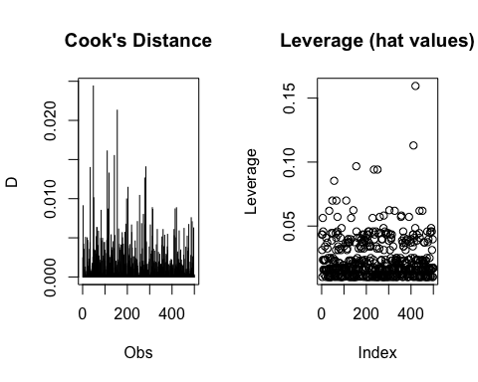
par(mfrow=c(1,1))
STEP 7: REMOVE OUTLIERS After the previous diagnostic we decided to remove outliers from the dataset if they are outside the 1.5*IQR range. After fitting a new model with the cleaned dataset we found this removed almost all of the observations where legal_cases_on_property = 1. So because that removed a significant portion of our model, we decided to stay with the original dataset despite there being some outliers and influential points.
remove_outliers <- function(df) {
df %>%
mutate(across(where(is.numeric),
~ ifelse(.x < quantile(.x, 0.25, na.rm = TRUE) - 1.5 * IQR(.x) |
.x > quantile(.x, 0.75, na.rm = TRUE) + 1.5 * IQR(.x),
NA, .x)))
}
df_clean <- remove_outliers(df) |>
drop_na()
#Fit a new model with cleaned dataframe
clean_fit <- lm(price ~ crime_cases_reported + legal_cases_on_property + crime_cases_reported * factor(city) + legal_cases_on_property*factor(city), data = df_clean)
summary(clean_fit)
##
## Call:
## lm(formula = price ~ crime_cases_reported + legal_cases_on_property +
## crime_cases_reported * factor(city) + legal_cases_on_property *
## factor(city), data = df_clean)
##
## Residuals:
## Min 1Q Median 3Q Max
## -1113845 -568190 47172 566116 1163865
##
## Coefficients: (4 not defined because of singularities)
## Estimate Std. Error t value
## (Intercept) 1347222 114070 11.810
## crime_cases_reported 10621 103385 0.103
## legal_cases_on_property NA NA NA
## factor(city)Liverpool -123072 153483 -0.802
## factor(city)London -115162 147510 -0.781
## factor(city)Manchester -149964 146066 -1.027
## crime_cases_reported:factor(city)Liverpool 11906 153091 0.078
## crime_cases_reported:factor(city)London 92410 141054 0.655
## crime_cases_reported:factor(city)Manchester -15472 134166 -0.115
## legal_cases_on_property:factor(city)Liverpool NA NA NA
## legal_cases_on_property:factor(city)London NA NA NA
## legal_cases_on_property:factor(city)Manchester NA NA NA
## Pr(>|t|)
## (Intercept) <2e-16 ***
## crime_cases_reported 0.918
## legal_cases_on_property NA
## factor(city)Liverpool 0.423
## factor(city)London 0.436
## factor(city)Manchester 0.305
## crime_cases_reported:factor(city)Liverpool 0.938
## crime_cases_reported:factor(city)London 0.513
## crime_cases_reported:factor(city)Manchester 0.908
## legal_cases_on_property:factor(city)Liverpool NA
## legal_cases_on_property:factor(city)London NA
## legal_cases_on_property:factor(city)Manchester NA
## ---
## Signif. codes: 0 '***' 0.001 '**' 0.01 '*' 0.05 '.' 0.1 ' ' 1
##
## Residual standard error: 641900 on 316 degrees of freedom
## Multiple R-squared: 0.01273, Adjusted R-squared: -0.009141
## F-statistic: 0.582 on 7 and 316 DF, p-value: 0.7705
res_clean <- resid(clean_fit)
fitted_clean <- fitted(clean_fit)
#Residual QQ Plot
qqnorm(res_clean, main = "Normal Q-Q Plot", xlab = "Residuals", ylab = "Sample Quantiles")
qqline(res_clean, col = "blue", lwd = 2)
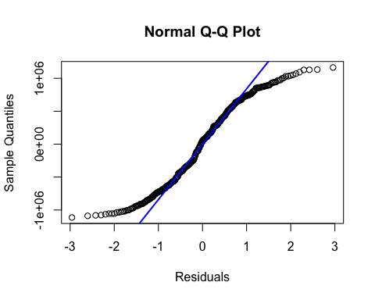
#Residual Plot
plot(fitted_clean, res_clean)
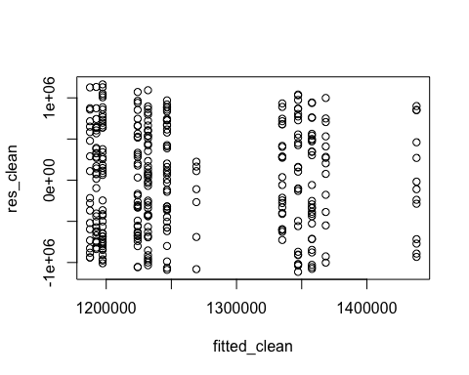
#Histogram of Residuals
hist(res_clean,
main = "Histogram of Residuals",
xlab = "Residuals",
ylab = "Frequency",
border = "black"
)
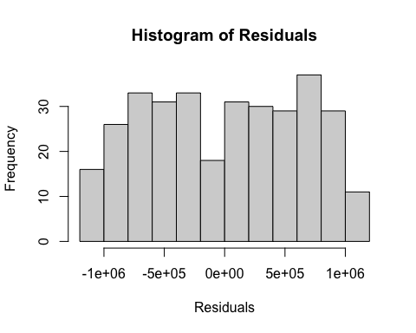
#Diagnostics
shapiro.test(res_clean)
##
## Shapiro-Wilk normality test
##
## data: res_clean
## W = 0.95196, p-value = 8.484e-09
bptest(clean_fit)
##
## studentized Breusch-Pagan test
##
## data: clean_fit
## BP = 9.6812, df = 7, p-value = 0.2074
# vif(clean_fit)
#Removing Outliers removed all 1's coded for Legal Cases On Property, so we choose to exclude removing outliers
STEP 8: WLS REGRESSION To combat the normality issue we ran a WLS regression. After fitting the model, Shapiro and BP tests came back ever so slightly improved from the original model, but due to time constraints we continued to bootstrapping for interpretation.
#Assign weights
ols_model <- lm(price ~ crime_cases_reported + legal_cases_on_property + crime_cases_reported * factor(city) + legal_cases_on_property*factor(city), data = df)
weights <- 1 / fitted(ols_model)^2
#WLS Model
wls_model <- lm(price ~ crime_cases_reported + legal_cases_on_property + crime_cases_reported * factor(city) + legal_cases_on_property*factor(city), data = df, weights = weights)
summary(wls_model)
##
## Call:
## lm(formula = price ~ crime_cases_reported + legal_cases_on_property +
## crime_cases_reported * factor(city) + legal_cases_on_property *
## factor(city), data = df, weights = weights)
##
## Weighted Residuals:
## Min 1Q Median 3Q Max
## -0.87779 -0.43046 0.00954 0.42457 1.18362
##
## Coefficients:
## Estimate Std. Error t value
## (Intercept) 1376445 106493 12.925
## crime_cases_reported 63586 76934 0.827
## legal_cases_on_property -281387 142526 -1.974
## factor(city)Liverpool -81268 135475 -0.600
## factor(city)London -58904 135541 -0.435
## factor(city)Manchester -205193 131265 -1.563
## crime_cases_reported:factor(city)Liverpool -57465 95200 -0.604
## crime_cases_reported:factor(city)London -101231 91881 -1.102
## crime_cases_reported:factor(city)Manchester -15079 96404 -0.156
## legal_cases_on_property:factor(city)Liverpool 32566 183984 0.177
## legal_cases_on_property:factor(city)London 267076 200698 1.331
## legal_cases_on_property:factor(city)Manchester 297059 185234 1.604
## Pr(>|t|)
## (Intercept) <2e-16 ***
## crime_cases_reported 0.4089
## legal_cases_on_property 0.0489 *
## factor(city)Liverpool 0.5489
## factor(city)London 0.6641
## factor(city)Manchester 0.1187
## crime_cases_reported:factor(city)Liverpool 0.5464
## crime_cases_reported:factor(city)London 0.2711
## crime_cases_reported:factor(city)Manchester 0.8758
## legal_cases_on_property:factor(city)Liverpool 0.8596
## legal_cases_on_property:factor(city)London 0.1839
## legal_cases_on_property:factor(city)Manchester 0.1094
## ---
## Signif. codes: 0 '***' 0.001 '**' 0.01 '*' 0.05 '.' 0.1 ' ' 1
##
## Residual standard error: 0.5116 on 488 degrees of freedom
## Multiple R-squared: 0.02719, Adjusted R-squared: 0.005264
## F-statistic: 1.24 on 11 and 488 DF, p-value: 0.2573
#Shapiro-Wilk
shapiro.test(resid(ols_model))
##
## Shapiro-Wilk normality test
##
## data: resid(ols_model)
## W = 0.96309, p-value = 6.996e-10
shapiro.test(resid(wls_model))
##
## Shapiro-Wilk normality test
##
## data: resid(wls_model)
## W = 0.9629, p-value = 6.482e-10
#Breusch-Pagan
bptest(ols_model)
##
## studentized Breusch-Pagan test
##
## data: ols_model
## BP = 6.361, df = 11, p-value = 0.8482
bptest(wls_model)
##
## studentized Breusch-Pagan test
##
## data: wls_model
## BP = 1.7361e-10, df = 11, p-value = 1
#Check Residual Plots after WLS Correction
res_wls <- resid(wls_model)
fitted_wls <- fitted(wls_model)
#Scatterplot of Residuals vs. Fitted
plot(fitted_wls, res_wls)
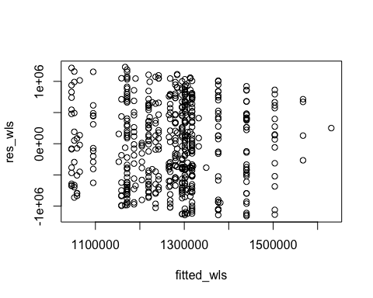
#Histogram of Residuals
hist(res_wls,
main = "Histogram of Residuals",
xlab = "Residuals",
ylab = "Frequency",
border = "black"
)
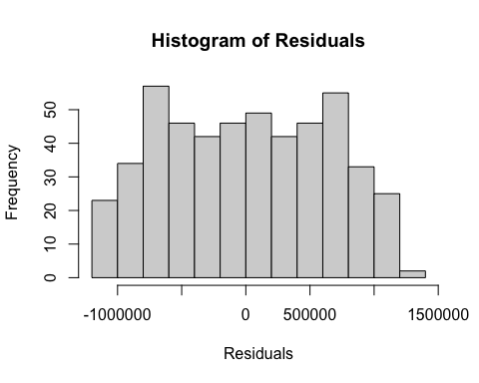 STEP 9: BOOTSTRAPPING In this section (Step 9 and Step 9 Cont.) we perform t-based confidence intervals and bootstrapped confidence intervals for both the ols and wls model to determine impact on normality. We found that in comparing the t-based CIs and bootstrapped CIs, they were very similar. The bootstrapped CIs appeared slightly narrower, but significance remained the same. Thus it would seem that WLS did little to fix the normality issue, but it was necessary to try. Time contraints limited from performing a robust regression model.
set.seed(321)
#Code taken from lecture notes Topic 21 WLS
#Build design matrix
X <- model.matrix(price ~ crime_cases_reported + legal_cases_on_property + crime_cases_reported * factor(city) + legal_cases_on_property*factor(city), data = df)
B <- 1000
n<- nrow(df)
#OLS Bootstrapping
boot_beta_ols <- matrix(NA_real_, nrow = B, ncol = length(coef(ols_model)))
for (b in 1:B) {
idx <- sample.int(n, n, replace = TRUE)
fb <- lm(price ~ crime_cases_reported + legal_cases_on_property + crime_cases_reported * factor(city) + legal_cases_on_property*factor(city), data = df[idx,])
boot_beta_ols[b, ] <- as.numeric(coef(fb))
}
ci_ols_boot <- t(apply(boot_beta_ols, 2, quantile, probs = c(0.025, 0.975)))
#WLS Bootstrapping
p <- length(coef(wls_model))
boot_b_wls <- matrix(NA_real_, nrow = B, ncol = p)
matrix(coef(wls_model), ncol = 1)
## [,1]
## [1,] 1376445.32
## [2,] 63585.88
## [3,] -281387.23
## [4,] -81267.83
## [5,] -58904.43
## [6,] -205193.01
## [7,] -57465.37
## [8,] -101231.38
## [9,] -15079.19
## [10,] 32566.45
## [11,] 267075.82
## [12,] 297058.96
for (b in 1:B) {
idx <- sample.int(n, size = n, replace = TRUE)
dat_b <- df[idx, ]
ols_b <- lm(price ~ crime_cases_reported + legal_cases_on_property + crime_cases_reported * factor(city) + legal_cases_on_property*factor(city), data = dat_b) #ols model on bootstrapped sample
w_b <- 1 / fitted(ols_b)^2 #compute weights
wls_b <- lm(price ~ crime_cases_reported + legal_cases_on_property + crime_cases_reported * factor(city) + legal_cases_on_property*factor(city), data = dat_b, weights = w_b)
boot_b_wls[b, ] <- as.numeric(coef(wls_b)) #pull all coefficients
}
ci_wls_boot <- t(apply(boot_b_wls, 2, quantile, probs = c(0.025, 0.975)))
STEP 9: CONT.
#OLS t-based CI
est_ols <- matrix(coef(ols_model), ncol = 1)
err_ols <- matrix(summary(ols_model)$coefficients[, c("Std. Error")])
nu_ols <- df.residual(ols_model)
tcrit_ols <- qt(0.975, df = nu_ols)
ci_ols_t_upper <- est_ols + tcrit_ols * err_ols
ci_ols_t_lower <- est_ols - tcrit_ols *err_ols
ci_ols_t <- cbind(ci_ols_t_lower, ci_ols_t_upper)
#WLS t-based CI
est_wls <- matrix(coef(wls_model), ncol = 1)
err_wls <- matrix(summary(wls_model)$coefficients[, c("Std. Error")])
nu_wls <- df.residual(wls_model)
tcrit_wls <- qt(0.975, df = nu_ols)
ci_wls_t_upper <- est_wls + tcrit_wls * err_wls
ci_wls_t_lower <- est_wls - tcrit_wls *err_wls
ci_wls_t <- cbind(ci_wls_t_lower, ci_wls_t_upper)
#WLS Confidence Interval Table with t-based and bootstrapped CIs
ols_tab <- data.frame(
Term <- colnames(X),#colnames( boot_b),
Beta_hat = coef(ols_model),
CI2.5_t <- ci_ols_t[,1],
CI97.5_t <- ci_ols_t[,2],
CI2.5 <- ci_ols_boot[,1],
CI97.5 <- ci_ols_boot[,2],
row.names = NULL
)
ols_tab
## Term....colnames.X. Beta_hat
## 1 (Intercept) 1360609.13
## 2 crime_cases_reported 83428.86
## 3 legal_cases_on_property -288764.27
## 4 factor(city)Liverpool -77333.51
## 5 factor(city)London -45749.46
## 6 factor(city)Manchester -189024.05
## 7 crime_cases_reported:factor(city)Liverpool -62499.08
## 8 crime_cases_reported:factor(city)London -118455.77
## 9 crime_cases_reported:factor(city)Manchester -37596.17
## 10 legal_cases_on_property:factor(city)Liverpool 32402.63
## 11 legal_cases_on_property:factor(city)London 275103.14
## 12 legal_cases_on_property:factor(city)Manchester 311617.76
## CI2.5_t....ci_ols_t...1. CI97.5_t....ci_ols_t...2. CI2.5....ci_ols_boot...1.
## 1 1169216.55 1552001.700 1155077.43
## 2 -49480.77 216338.492 -36880.45
## 3 -579065.55 1537.017 -595071.27
## 4 -329281.14 174614.120 -322762.10
## 5 -294877.47 203378.540 -292758.82
## 6 -437584.75 59536.657 -459811.85
## 7 -236439.19 111441.021 -222561.02
## 8 -285052.14 48140.603 -278662.44
## 9 -213014.06 137821.722 -213286.25
## 10 -355361.84 420167.108 -394257.06
## 11 -124623.89 674830.170 -154638.15
## 12 -63235.11 686470.635 -100166.96
## CI97.5....ci_ols_boot...2.
## 1 1566951.45
## 2 204196.05
## 3 58776.20
## 4 181884.34
## 5 221336.59
## 6 89055.11
## 7 102299.39
## 8 44779.02
## 9 139523.69
## 10 447006.63
## 11 650588.76
## 12 701242.84
#WLS Confidence Interval Table with t-based and bootstrapped CIs
wls_tab <- data.frame(
Term <- colnames(X),#colnames( boot_b),
Beta_hat = coef(wls_model),
CI2.5_t <- ci_wls_t[,1],
CI97.5_t <- ci_wls_t[,2],
CI2.5 <- ci_wls_boot[,1],
CI97.5 <- ci_wls_boot[,2],
row.names = NULL
)
wls_tab
## Term....colnames.X. Beta_hat
## 1 (Intercept) 1376445.32
## 2 crime_cases_reported 63585.88
## 3 legal_cases_on_property -281387.23
## 4 factor(city)Liverpool -81267.83
## 5 factor(city)London -58904.43
## 6 factor(city)Manchester -205193.01
## 7 crime_cases_reported:factor(city)Liverpool -57465.37
## 8 crime_cases_reported:factor(city)London -101231.38
## 9 crime_cases_reported:factor(city)Manchester -15079.19
## 10 legal_cases_on_property:factor(city)Liverpool 32566.45
## 11 legal_cases_on_property:factor(city)London 267075.82
## 12 legal_cases_on_property:factor(city)Manchester 297058.96
## CI2.5_t....ci_wls_t...1. CI97.5_t....ci_wls_t...2. CI2.5....ci_wls_boot...1.
## 1 1167203.26 1585687.387 1158107.9
## 2 -87576.13 214747.904 -50261.0
## 3 -561427.68 -1346.768 -584923.6
## 4 -347453.83 184918.180 -330349.8
## 5 -325219.87 207411.014 -304888.8
## 6 -463106.70 52720.673 -461989.7
## 7 -244518.67 129587.928 -220137.9
## 8 -281761.73 79298.965 -259126.0
## 9 -204496.29 174337.914 -196654.7
## 10 -328932.83 394065.724 -357183.4
## 11 -127262.08 661413.724 -160545.2
## 12 -66895.47 661013.382 -122213.1
## CI97.5....ci_wls_boot...2.
## 1 1564476.14
## 2 190425.89
## 3 32238.98
## 4 191012.80
## 5 199962.57
## 6 57399.92
## 7 112424.27
## 8 62399.73
## 9 166970.45
## 10 422995.00
## 11 643467.88
## 12 700598.93
STEP 10: RIDGE REGRESSION Lastly to address multicollinerity concens we performed ridge regression which inflates the diagonal by lambda. Results are presented in the next step.
X_w <- model.matrix(price ~ crime_cases_reported + legal_cases_on_property + crime_cases_reported * factor(city) + legal_cases_on_property*factor(city), data = df, weights = weights)
vif(wls_model)
## GVIF Df GVIF^(1/(2*Df))
## crime_cases_reported 7.076780 1 2.660222
## legal_cases_on_property 5.059031 1 2.249229
## factor(city) 11.626424 3 1.505131
## crime_cases_reported:factor(city) 27.354808 3 1.735824
## legal_cases_on_property:factor(city) 10.384006 3 1.477046
#Code taken from lecture notes Topic 21 Ridge Regression
#10-fold cross validations
cv_ridge <- cv.glmnet(X_w, df$price, alpha =0)
lambda_min <- cv_ridge$lambda.min
cat("\n --- Lambda Min --- \n")
##
## --- Lambda Min ---
lambda_min #find the lambda that minimizes cross-val. error
## [1] 1866304
ridge_fit <- glmnet(X_w, df$price, alpha = 0)
plot(ridge_fit, xvar = "lambda", label = TRUE)
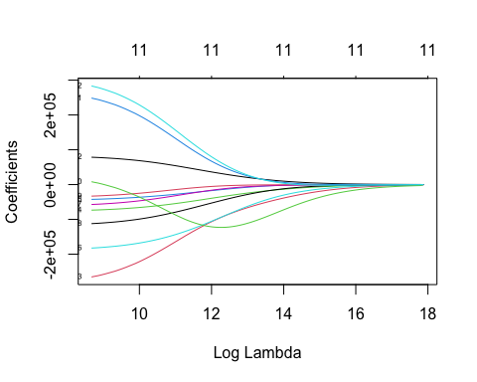
cat("\n --- Ridge Coefficients --- \n")
##
## --- Ridge Coefficients ---
beta <- coef(ridge_fit, s = lambda_min)[-2] #Take beta coefficients corresponding to the lambda min value
#excluding the second entry
STEP 11: RIDGE REGRESSION BOOTSTRAPPING Results from the bootstrapped confidence intervals showed very similar to the WLS regression. Again only the intercept has a significant confidence interval, and the intervals overall seem to overlap still indicating collinearity. So that indicates that impacts may not be statistically significant.
set.seed(321)
#Code taken from lecture notes Topic 21 Ridge Regression
B <- 1000
p <- ncol(X_w)
boot_b <- matrix(NA_real_, nrow = B, ncol = p)
colnames(boot_b) <- colnames(X_w)
n <- nrow(X_w)
for (b in 1:B) {
idx <- sample.int(n, size = n, replace = TRUE)
fit_b <- glmnet(X_w[idx, ], df$price[idx], alpha = 0,
lambda = lambda_min, standardize = FALSE)
boot_b[b, ] <- as.numeric(coef(fit_b))[-2]
}
ci_coef <- t(apply(boot_b, 2, quantile, probs = c(0.025, 0.975)))
#Ridge Regression table with confidence intervals
ridge_tab <- data.frame(
Term = colnames(boot_b),
Beta_hat = beta,
CI2.5 = ci_coef[, 1],
CI97.5 = ci_coef[,2],
row.names = NULL
)
cat("\n --- Ridge Regression Table --- \n"); ridge_tab
##
## --- Ridge Regression Table ---
## Term Beta_hat CI2.5
## 1 (Intercept) 1286834.0348 1211620.852
## 2 crime_cases_reported 6777.6931 -7751.692
## 3 legal_cases_on_property -29126.8772 -15904.092
## 4 factor(city)Liverpool -9829.0322 -10119.805
## 5 factor(city)London -473.7601 -5977.256
## 6 factor(city)Manchester -20949.1039 -12166.055
## 7 crime_cases_reported:factor(city)Liverpool -1709.7537 -11876.866
## 8 crime_cases_reported:factor(city)London -7802.7306 -14097.943
## 9 crime_cases_reported:factor(city)Manchester -571.9279 -11230.511
## 10 legal_cases_on_property:factor(city)Liverpool -55092.8214 -9826.218
## 11 legal_cases_on_property:factor(city)London 2662.0607 -3985.886
## 12 legal_cases_on_property:factor(city)Manchester -193.9240 -5447.363
## CI97.5
## 1 1327970.2495
## 2 21445.7924
## 3 371.2091
## 4 4619.3239
## 5 7458.8669
## 6 2630.8566
## 7 8878.1701
## 8 7697.7338
## 9 9254.8301
## 10 -145.6923
## 11 3721.1800
## 12 3970.6411
STEP 12: HYPOTHESIS TEST Lastly for the individual portion of the project, I ran an anova test test our hypothesis: whether there were any overall regional effects. The full model contains everything with the interaction terms and factor(city), while the reduced models consider those betas equal to 0. After running it we get a p-value > 0.05 so e fail to reject the null hypothesis and conclude that there do not appear to by any overall regional effects. Intuitively this makes sense since Birmingham, London, Liverpool, and Manchester are all very similar cities. They are all about the same size, people will have the same socieoeconomic status, economies will be about the same, and thus crime would be about the same. So while it woud be plausible to assume that city would affect price, in this case, with the data in this dataset, it makes sense that no significant regional effects would be found.
full_model <- lm(price ~ crime_cases_reported + legal_cases_on_property + crime_cases_reported * factor(city) + legal_cases_on_property*factor(city), data = df, weights = weights)
reduced_model <- lm(price ~ crime_cases_reported + legal_cases_on_property, data = df, weights = weights)
anova(reduced_model, full_model)
## Analysis of Variance Table
##
## Model 1: price ~ crime_cases_reported + legal_cases_on_property
## Model 2: price ~ crime_cases_reported + legal_cases_on_property + crime_cases_reported *
## factor(city) + legal_cases_on_property * factor(city)
## Res.Df RSS Df Sum of Sq F Pr(>F)
## 1 497 130.11
## 2 488 127.70 9 2.4048 1.0211 0.4218
STEP 13: COMBINED MODEL For this mode, another group memeber performed model selection strategies and the following predictors were chosen for the full model: property size, satisfaction score, EMI to income ratio, and city which we used as an interaction term. Since exploratory plots were already generated in other models, we jumped right into fitting a model. Similar to almost all of the other individual models we chose, we found non-normality, little evidence for heterscedasticity, and medium/high multicollinearity, so diagnostics and remedies will look similar to the model on location characteristics.
# How do city level differences shape the impact of property size, emi to income
# ratio and satisfaction score on housing prices?
Model <- lm(price ~ property_size_sqft + satisfaction_score + emi_to_income_ratio +
property_size_sqft*factor(city) + satisfaction_score*factor(city) +
emi_to_income_ratio*factor(city), data = df)
summary(Model)
##
## Call:
## lm(formula = price ~ property_size_sqft + satisfaction_score +
## emi_to_income_ratio + property_size_sqft * factor(city) +
## satisfaction_score * factor(city) + emi_to_income_ratio *
## factor(city), data = df)
##
## Residuals:
## Min 1Q Median 3Q Max
## -6041.5 -2490.5 -10.5 2384.7 5451.6
##
## Coefficients:
## Estimate Std. Error t value
## (Intercept) -3.975e+02 8.698e+02 -0.457
## property_size_sqft 3.999e+02 1.944e-01 2056.746
## satisfaction_score 2.213e+02 1.074e+02 2.061
## emi_to_income_ratio -6.415e+02 1.544e+03 -0.416
## factor(city)Liverpool 2.819e+02 1.198e+03 0.235
## factor(city)London -2.152e+00 1.215e+03 -0.002
## factor(city)Manchester -2.533e+02 1.123e+03 -0.226
## property_size_sqft:factor(city)Liverpool 5.779e-02 2.674e-01 0.216
## property_size_sqft:factor(city)London 1.698e-01 2.822e-01 0.602
## property_size_sqft:factor(city)Manchester 5.496e-01 2.685e-01 2.047
## satisfaction_score:factor(city)Liverpool -1.414e+02 1.396e+02 -1.013
## satisfaction_score:factor(city)London -1.280e+02 1.428e+02 -0.896
## satisfaction_score:factor(city)Manchester -1.290e+02 1.378e+02 -0.936
## emi_to_income_ratio:factor(city)Liverpool 4.410e+02 2.331e+03 0.189
## emi_to_income_ratio:factor(city)London -2.591e+03 2.793e+03 -0.928
## emi_to_income_ratio:factor(city)Manchester -4.772e+03 2.828e+03 -1.688
## Pr(>|t|)
## (Intercept) 0.6478
## property_size_sqft <2e-16 ***
## satisfaction_score 0.0398 *
## emi_to_income_ratio 0.6779
## factor(city)Liverpool 0.8140
## factor(city)London 0.9986
## factor(city)Manchester 0.8216
## property_size_sqft:factor(city)Liverpool 0.8290
## property_size_sqft:factor(city)London 0.5476
## property_size_sqft:factor(city)Manchester 0.0412 *
## satisfaction_score:factor(city)Liverpool 0.3115
## satisfaction_score:factor(city)London 0.3704
## satisfaction_score:factor(city)Manchester 0.3495
## emi_to_income_ratio:factor(city)Liverpool 0.8500
## emi_to_income_ratio:factor(city)London 0.3541
## emi_to_income_ratio:factor(city)Manchester 0.0921 .
## ---
## Signif. codes: 0 '***' 0.001 '**' 0.01 '*' 0.05 '.' 0.1 ' ' 1
##
## Residual standard error: 2910 on 484 degrees of freedom
## Multiple R-squared: 1, Adjusted R-squared: 1
## F-statistic: 1.63e+06 on 15 and 484 DF, p-value: < 2.2e-16
#Diagnostics
res_Model <- resid(Model)
fitted_Model <- fitted(Model)
#Scatterplot of Residuals vs. Fitted
plot(fitted_Model, res_Model,
xlab = "Fitted Values",
ylab = "Residuals",
main = "Residuals vs. Fitted")
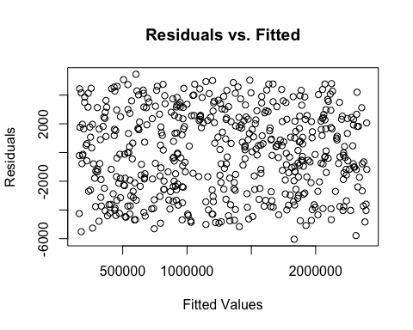
#Histogram of Residuals
hist(res_Model,
main = "Histogram of Residuals",
xlab = "Residuals",
ylab = "Frequency",
border = "black"
)
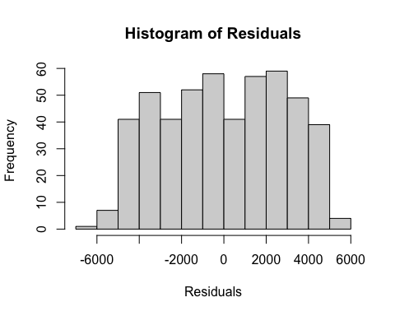
#QQ Plot of Residuals
qqnorm(res_Model, main = "Normal Q-Q Plot", xlab = "Residuals", ylab = "Sample Quantiles")
qqline(res_Model, col = "blue", lwd = 2)
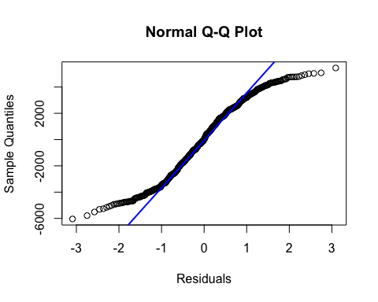
#multicollinearity (VIF)
vif(Model)
## GVIF Df GVIF^(1/(2*Df))
## property_size_sqft 5.778794 1 2.403912
## satisfaction_score 5.442146 1 2.332841
## emi_to_income_ratio 3.732059 1 1.931854
## factor(city) 904.842569 3 3.110013
## property_size_sqft:factor(city) 499.498880 3 2.816798
## satisfaction_score:factor(city) 244.130564 3 2.499983
## emi_to_income_ratio:factor(city) 36.987130 3 1.825332
#normality (Shapiro Test)
shapiro.test(res_Model)
##
## Shapiro-Wilk normality test
##
## data: res_Model
## W = 0.9625, p-value = 5.527e-10
#heteroscedasticity (Breusch-Pagan Test)
bptest(Model)
##
## studentized Breusch-Pagan test
##
## data: Model
## BP = 7.6055, df = 15, p-value = 0.9386
# Diagnostic tests:
# property size is significant as well as satisfaction score and property size and manchester
# Residuals are not normal. But no heterscedasticity and no quadratic pattern.
# Multicollinearity: all are concerning or severe except emi to income ratio
STEP 14: OUTLIERS Since we had non-normality we assessed outliers and influential points. Again Cook’d D cutoff flagged a good amount of points as well as the leverage graph and influence plot. So, we tried removing outliers. This time the Shapiro p-value increased enough to justify using the cleaned dataset moving forward.
#Identifying Outliers and Influential Points
#diagnostics
lev_h <- hatvalues(Model)
t_stud <- rstudent(Model)
cookD <- cooks.distance(Model)
n <- nrow(df); p <- length(coef(Model))
lev_cut <- 2*p/n
cook_cut <- 4/n
#Top influential candidates
sum_influence <- data.frame(
id = seq_len(n),
fitted = fitted_Model,
Leverage = lev_h,
rStud = t_stud,
CooksD = cookD,
flag_lev = lev_h > lev_cut,
flag_cook = cookD > cook_cut,
flag_large_resid = abs(t_stud) > 3
)
#First 10 greatest influenced values by Cook's Distance cutoff
head(sum_influence[order(-sum_influence$CooksD), ], 10)
## id fitted Leverage rStud CooksD flag_lev flag_cook
## 26 26 1198609.5 0.17420687 1.9006947 0.047376253 TRUE TRUE
## 196 196 1846522.5 0.27864509 -1.0367319 0.025944672 TRUE TRUE
## 152 152 1915181.0 0.10944307 1.4104787 0.015249398 TRUE TRUE
## 369 369 1599749.2 0.11508853 -1.3673451 0.015170115 TRUE TRUE
## 368 368 1322303.4 0.07052561 -1.5716937 0.011679064 TRUE TRUE
## 182 182 1963849.8 0.20934783 -0.8111036 0.010894887 TRUE TRUE
## 414 414 177483.0 0.04172396 -1.9405041 0.010188953 FALSE TRUE
## 35 35 603003.4 0.04185942 1.9188957 0.009998771 FALSE TRUE
## 33 33 164729.9 0.05989307 1.5743770 0.009839477 FALSE TRUE
## 359 359 1873992.8 0.25204168 0.6683424 0.009418242 TRUE TRUE
## flag_large_resid
## 26 FALSE
## 196 FALSE
## 152 FALSE
## 369 FALSE
## 368 FALSE
## 182 FALSE
## 414 FALSE
## 35 FALSE
## 33 FALSE
## 359 FALSE
#Cook's Distance Plot
par(mfrow = c(1,2))
plot(cookD, type="h", main="Cook's Distance", ylab="D", xlab="Obs")
abline(lev = cook_cut, lty=2)
#Leverage Plot
plot(lev_h, ylab="Leverage", main="Leverage (hat values)")
abline(lev_h=lev_cut, lty=2)
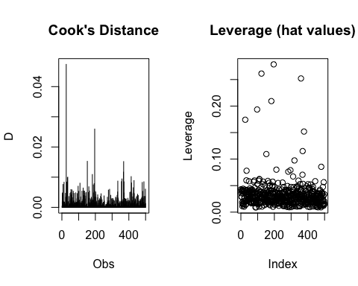
par(mfrow=c(1,1))
#Influence Plot
influencePlot(Model,
scale = 1,
fill = FALSE,
#col = c("black", "red"),
id.method = "noteworthy",
grid = TRUE,
main = "Influence Plot")
## StudRes Hat CookD
## 26 1.900694685 0.17420687 4.737625e-02
## 123 -0.006775665 0.26126454 1.016889e-06
## 135 -2.103284132 0.01909724 5.345143e-03
## 196 -1.036731860 0.27864509 2.594467e-02
## 334 -2.028337880 0.03292257 8.697766e-03
abline(v = lev_cut, lty = 2)
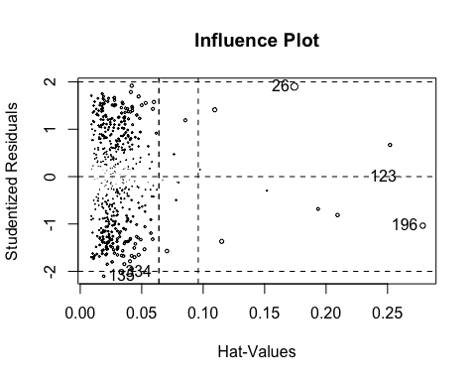
dev.off #Influence plot flags 5 points
## function (which = dev.cur())
## {
## if (which == 1)
## stop("cannot shut down device 1 (the null device)")
## .External(C_devoff, as.integer(which))
## dev.cur()
## }
## <bytecode: 0x7fedac3e1838>
## <environment: namespace:grDevices>
#Try Removing Outliers
remove_outliers <- function(df) {
df %>%
mutate(across(where(is.numeric),
~ ifelse(.x < quantile(.x, 0.25, na.rm = TRUE) - 1.5 * IQR(.x) |
.x > quantile(.x, 0.75, na.rm = TRUE) + 1.5 * IQR(.x),
NA, .x)))
}
df_clean <- remove_outliers(df) |>
drop_na()
#Model with removed potential outliers
clean_Model <- lm(price ~ property_size_sqft + satisfaction_score + emi_to_income_ratio +
property_size_sqft*factor(city) + satisfaction_score*factor(city) +
emi_to_income_ratio*factor(city), data = df_clean)
#Summary
summary(clean_Model)
##
## Call:
## lm(formula = price ~ property_size_sqft + satisfaction_score +
## emi_to_income_ratio + property_size_sqft * factor(city) +
## satisfaction_score * factor(city) + emi_to_income_ratio *
## factor(city), data = df_clean)
##
## Residuals:
## Min 1Q Median 3Q Max
## -6361 -2353 224 2454 5152
##
## Coefficients:
## Estimate Std. Error t value
## (Intercept) 2.724e+01 1.064e+03 0.026
## property_size_sqft 3.996e+02 2.749e-01 1453.711
## satisfaction_score 2.464e+02 1.340e+02 1.839
## emi_to_income_ratio 3.804e+03 4.349e+03 0.875
## factor(city)Liverpool 8.459e+02 1.490e+03 0.568
## factor(city)London 5.275e+02 1.520e+03 0.347
## factor(city)Manchester -1.071e+03 1.391e+03 -0.770
## property_size_sqft:factor(city)Liverpool 5.410e-01 3.676e-01 1.472
## property_size_sqft:factor(city)London 4.366e-01 3.806e-01 1.147
## property_size_sqft:factor(city)Manchester 8.393e-01 3.633e-01 2.310
## satisfaction_score:factor(city)Liverpool -2.877e+02 1.721e+02 -1.671
## satisfaction_score:factor(city)London -2.114e+02 1.754e+02 -1.205
## satisfaction_score:factor(city)Manchester -7.035e+01 1.722e+02 -0.409
## emi_to_income_ratio:factor(city)Liverpool -5.941e+03 5.779e+03 -1.028
## emi_to_income_ratio:factor(city)London -1.183e+04 6.521e+03 -1.814
## emi_to_income_ratio:factor(city)Manchester -8.299e+03 5.743e+03 -1.445
## Pr(>|t|)
## (Intercept) 0.9796
## property_size_sqft <2e-16 ***
## satisfaction_score 0.0669 .
## emi_to_income_ratio 0.3824
## factor(city)Liverpool 0.5707
## factor(city)London 0.7288
## factor(city)Manchester 0.4420
## property_size_sqft:factor(city)Liverpool 0.1421
## property_size_sqft:factor(city)London 0.2522
## property_size_sqft:factor(city)Manchester 0.0216 *
## satisfaction_score:factor(city)Liverpool 0.0957 .
## satisfaction_score:factor(city)London 0.2290
## satisfaction_score:factor(city)Manchester 0.6831
## emi_to_income_ratio:factor(city)Liverpool 0.3048
## emi_to_income_ratio:factor(city)London 0.0706 .
## emi_to_income_ratio:factor(city)Manchester 0.1495
## ---
## Signif. codes: 0 '***' 0.001 '**' 0.01 '*' 0.05 '.' 0.1 ' ' 1
##
## Residual standard error: 2909 on 308 degrees of freedom
## Multiple R-squared: 1, Adjusted R-squared: 1
## F-statistic: 1.039e+06 on 15 and 308 DF, p-value: < 2.2e-16
#Resdiuals and Fitted Values
res_clean_Model <- resid(clean_Model)
fitted_clean_Model <- fitted(clean_Model)
#Residual QQ Plot (Outliers removed)
qqnorm(res_clean_Model, main = "Normal Q-Q Plot", xlab = "Residuals", ylab = "Sample Quantiles")
qqline(res_clean_Model, col = "blue", lwd = 2)
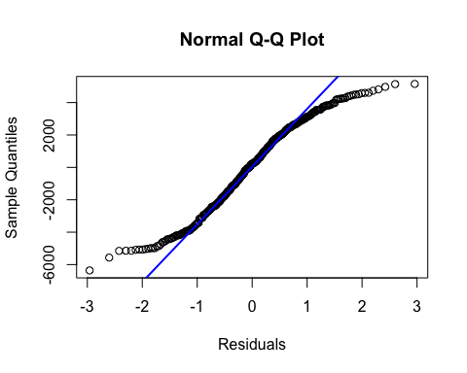
#Residual Plot (Outliers removed)
plot(fitted_clean_Model, res_clean_Model)
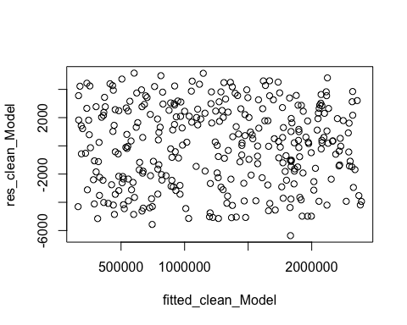
#Histogram of Residuals (Outliers removed)
hist(res_clean_Model,
main = "Histogram of Residuals",
xlab = "Residuals",
ylab = "Frequency",
border = "black"
)
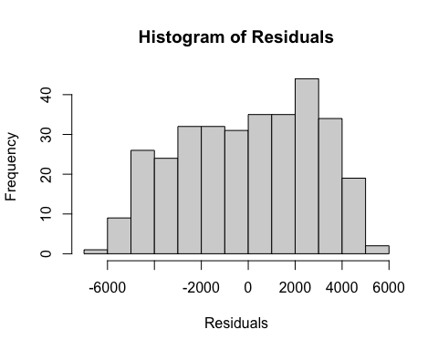
shapiro.test(res_clean_Model)
##
## Shapiro-Wilk normality test
##
## data: res_clean_Model
## W = 0.9645, p-value = 4.152e-07
bptest(clean_Model)
##
## studentized Breusch-Pagan test
##
## data: clean_Model
## BP = 16.027, df = 15, p-value = 0.3803
# Removal of outliers did not do much to improve the model
# Satisfaction score became not significant
# In the next steps we will perform weighted least squares to see if that will
# lessen the effects of the extreme points
STEP 15: WEIGHTED LEAST SQUARES Again we want to see if we can lessen the effect of the extreme values by doing a Weighted Least Squares Regression. Running residual diagnostics on the new model showed that the Shapiro p-value increased signficantly. So we will used the WLS model in our Ridge regression and in the Anova test.
#Assign weights
ols_Model <- lm(price ~ property_size_sqft + satisfaction_score + emi_to_income_ratio +
property_size_sqft*factor(city) + satisfaction_score*factor(city) +
emi_to_income_ratio*factor(city), data = df_clean)
Weights <- 1 / fitted(ols_Model)^2
#WLS Model
wls_Model <- lm(price ~ property_size_sqft + satisfaction_score + emi_to_income_ratio +
property_size_sqft*factor(city) + satisfaction_score*factor(city) +
emi_to_income_ratio*factor(city), data = df_clean, weights = Weights)
summary(wls_Model)
##
## Call:
## lm(formula = price ~ property_size_sqft + satisfaction_score +
## emi_to_income_ratio + property_size_sqft * factor(city) +
## satisfaction_score * factor(city) + emi_to_income_ratio *
## factor(city), data = df_clean, weights = Weights)
##
## Weighted Residuals:
## Min 1Q Median 3Q Max
## -0.0260014 -0.0020027 0.0002446 0.0020165 0.0198332
##
## Coefficients:
## Estimate Std. Error t value
## (Intercept) 2.795e+02 1.046e+03 0.267
## property_size_sqft 3.995e+02 5.408e-01 738.738
## satisfaction_score 2.604e+01 1.672e+02 0.156
## emi_to_income_ratio 1.129e+04 9.365e+03 1.206
## factor(city)Liverpool 3.036e+03 1.268e+03 2.394
## factor(city)London 1.235e+03 1.776e+03 0.696
## factor(city)Manchester -9.090e+02 1.253e+03 -0.725
## property_size_sqft:factor(city)Liverpool 8.195e-01 6.523e-01 1.256
## property_size_sqft:factor(city)London -1.885e-01 7.284e-01 -0.259
## property_size_sqft:factor(city)Manchester 8.484e-01 6.794e-01 1.249
## satisfaction_score:factor(city)Liverpool -2.293e+02 1.927e+02 -1.190
## satisfaction_score:factor(city)London -1.349e+02 2.386e+02 -0.565
## satisfaction_score:factor(city)Manchester 1.948e+02 1.957e+02 0.995
## emi_to_income_ratio:factor(city)Liverpool -3.217e+04 1.124e+04 -2.862
## emi_to_income_ratio:factor(city)London -4.276e+03 1.328e+04 -0.322
## emi_to_income_ratio:factor(city)Manchester -2.189e+04 1.147e+04 -1.908
## Pr(>|t|)
## (Intercept) 0.78944
## property_size_sqft < 2e-16 ***
## satisfaction_score 0.87636
## emi_to_income_ratio 0.22870
## factor(city)Liverpool 0.01728 *
## factor(city)London 0.48717
## factor(city)Manchester 0.46889
## property_size_sqft:factor(city)Liverpool 0.20995
## property_size_sqft:factor(city)London 0.79597
## property_size_sqft:factor(city)Manchester 0.21273
## satisfaction_score:factor(city)Liverpool 0.23487
## satisfaction_score:factor(city)London 0.57236
## satisfaction_score:factor(city)Manchester 0.32039
## emi_to_income_ratio:factor(city)Liverpool 0.00449 **
## emi_to_income_ratio:factor(city)London 0.74777
## emi_to_income_ratio:factor(city)Manchester 0.05730 .
## ---
## Signif. codes: 0 '***' 0.001 '**' 0.01 '*' 0.05 '.' 0.1 ' ' 1
##
## Residual standard error: 0.004608 on 308 degrees of freedom
## Multiple R-squared: 1, Adjusted R-squared: 1
## F-statistic: 4.414e+05 on 15 and 308 DF, p-value: < 2.2e-16
#Shapiro-Wilk
shapiro.test(resid(ols_Model))
##
## Shapiro-Wilk normality test
##
## data: resid(ols_Model)
## W = 0.9645, p-value = 4.152e-07
shapiro.test(resid(wls_Model))
##
## Shapiro-Wilk normality test
##
## data: resid(wls_Model)
## W = 0.97943, p-value = 0.000135
#Breusch-Pagan
bptest(ols_Model)
##
## studentized Breusch-Pagan test
##
## data: ols_Model
## BP = 16.027, df = 15, p-value = 0.3803
bptest(wls_Model)
##
## studentized Breusch-Pagan test
##
## data: wls_Model
## BP = 2.9733e-10, df = 15, p-value = 1
#Check Residual Plots after WLS Correction
res_wls_Model <- resid(wls_Model)
fitted_wls_Model <- fitted(wls_Model)
plot(fitted_wls_Model, res_wls_Model)
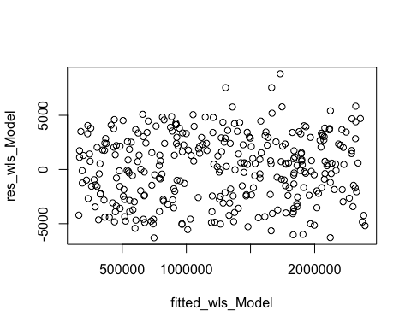
#Histogram of WLS residuals
hist(res_wls_Model,
main = "Histogram of Residuals",
xlab = "Residuals",
ylab = "Frequency",
border = "black"
)
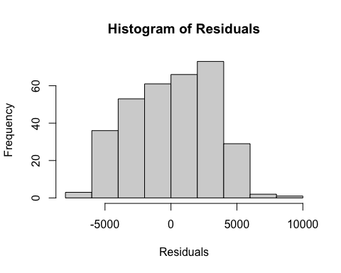
#QQ Plot of Residuals
qqnorm(res_wls_Model, main = "Normal Q-Q Plot after WLS", xlab = "Residuals", ylab = "Sample Quantiles")
qqline(res_wls_Model, col = "blue", lwd = 2)
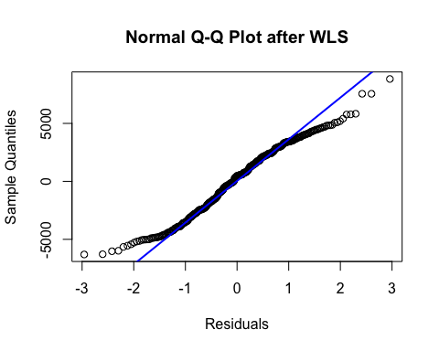
#Check Multicollinearity
vif(wls_Model)
## GVIF Df GVIF^(1/(2*Df))
## property_size_sqft 12.118493 1 3.481163
## satisfaction_score 8.225574 1 2.868026
## emi_to_income_ratio 11.933376 1 3.454472
## factor(city) 630.846190 3 2.928559
## property_size_sqft:factor(city) 273.510416 3 2.547782
## satisfaction_score:factor(city) 720.469981 3 2.994121
## emi_to_income_ratio:factor(city) 167.835733 3 2.348627
# Weighted least squares significantly improved the Shapiro Wilk p-value
STEP 16: BOOTSTRAPPING Summary (step 16 and step 16 cont.): Here we apply bootstrapping so we can see through confidence intervals the effect of the weighted model, and nwo we have the ability to interpret coefficients. The confidence intervals show that Property size as well as the EMI ratio with Manchester were significant, with Property size being the most significant. Since this result appeared in both the OLS and WLS model summary and the WLS bootstrapped CIs, we can confidently say that property size has a statistically significant influence on the price of a house in the UK. Again the bootstrapped confidence intervals are roughly similar to the t-based CIs. Maybe slightly higher showing a slightly stronger estimate, but not by that much. Overall the Weighted Least Squares method did help in reducing issues with normality in this final model.
X_M <- model.matrix(price ~ property_size_sqft + satisfaction_score + emi_to_income_ratio +
property_size_sqft*factor(city) + satisfaction_score*factor(city) +
emi_to_income_ratio*factor(city), data = df_clean)
B <- 1000
n<- nrow(df_clean)
p <- length(coef(wls_Model))
boot_b_wls_Model <- matrix(NA_real_, nrow = B, ncol = p)
#OLS Bootstrapping
boot_beta_ols_M <- matrix(NA_real_, nrow = B, ncol = length(coef(ols_Model)))
for (b in 1:B) {
idx <- sample.int(n, n, replace = TRUE)
fb <- lm(price ~ property_size_sqft + satisfaction_score + emi_to_income_ratio +
property_size_sqft*factor(city) + satisfaction_score*factor(city) +
emi_to_income_ratio*factor(city), data = df_clean[idx,])
boot_beta_ols_M[b, ] <- as.numeric(coef(fb))
}
ci_ols_boot_Model <- t(apply(boot_beta_ols_M, 2, quantile, probs = c(0.025, 0.975)))
#WLS Bootstrapping
for (b in 1:B) {
idx <- sample.int(n, size = n, replace = TRUE)
dat_b <- df_clean[idx, ]
ols_b <- lm(price ~ property_size_sqft + satisfaction_score + emi_to_income_ratio +
property_size_sqft*factor(city) + satisfaction_score*factor(city) +
emi_to_income_ratio*factor(city), data = dat_b) #ols model on bootstrapped sample
w_b <- 1 / fitted(ols_b)^2 #compute weights
wls_b <- lm(price ~ property_size_sqft + satisfaction_score + emi_to_income_ratio +
property_size_sqft*factor(city) + satisfaction_score*factor(city) +
emi_to_income_ratio*factor(city), data = dat_b, weights = w_b)
boot_b_wls_Model[b, ] <- as.numeric(coef(wls_b)) #pull all coefficients
}
ci_wls_boot_Model <- t(apply(boot_b_wls_Model, 2, quantile, probs = c(0.025, 0.975)))
STEP 16: CONT.
#OLS t-based CI
est_ols_M <- matrix(coef(ols_Model), ncol = 1)
err_ols_M <- matrix(summary(ols_Model)$coefficients[, c("Std. Error")])
nu_ols_M <- df.residual(ols_Model)
tcrit_ols_M <- qt(0.975, df = nu_ols_M)
ci_ols_t_upper_M <- est_ols_M + tcrit_ols_M * err_ols_M
ci_ols_t_lower_M <- est_ols_M - tcrit_ols_M *err_ols_M
ci_ols_t_M <- cbind(ci_ols_t_lower_M, ci_ols_t_upper_M)
#WLS t-based CI
est_wls_M <- matrix(coef(wls_Model), ncol = 1) #extract estimate
err_wls_M <- matrix(summary(wls_Model)$coefficients[, c("Std. Error")]) #extract sd
nu_wls_M <- df.residual(wls_Model)
tcrit_wls_M <- qt(0.975, df = nu_ols_M)
ci_wls_t_upper_M <- est_wls_M + tcrit_wls_M * err_wls_M
ci_wls_t_lower_M <- est_wls_M - tcrit_wls_M *err_wls_M
ci_wls_t_M <- cbind(ci_wls_t_lower_M, ci_wls_t_upper_M)
#OLS Confidence Interval Table with t-based and bootstrapped CIs
ols_tab_Model <- data.frame(
Term <- colnames(X_M),
Beta_hat = coef(ols_Model),
CI2.5_t <- ci_ols_t_M[,1],
CI97.5_t <- ci_ols_t_M[,2],
CI2.5 <- ci_ols_boot_Model[,1],
CI97.5 <- ci_ols_boot_Model[,2],
row.names = NULL
)
ols_tab_Model
## Term....colnames.X_M. Beta_hat
## 1 (Intercept) 2.724486e+01
## 2 property_size_sqft 3.995607e+02
## 3 satisfaction_score 2.464459e+02
## 4 emi_to_income_ratio 3.803897e+03
## 5 factor(city)Liverpool 8.458716e+02
## 6 factor(city)London 5.274502e+02
## 7 factor(city)Manchester -1.070637e+03
## 8 property_size_sqft:factor(city)Liverpool 5.410243e-01
## 9 property_size_sqft:factor(city)London 4.365524e-01
## 10 property_size_sqft:factor(city)Manchester 8.392918e-01
## 11 satisfaction_score:factor(city)Liverpool -2.877193e+02
## 12 satisfaction_score:factor(city)London -2.113939e+02
## 13 satisfaction_score:factor(city)Manchester -7.035288e+01
## 14 emi_to_income_ratio:factor(city)Liverpool -5.940705e+03
## 15 emi_to_income_ratio:factor(city)London -1.183078e+04
## 16 emi_to_income_ratio:factor(city)Manchester -8.299176e+03
## CI2.5_t....ci_ols_t_M...1. CI97.5_t....ci_ols_t_M...2.
## 1 -2.065724e+03 2120.213452
## 2 3.990199e+02 400.101577
## 3 -1.730856e+01 510.200344
## 4 -4.753477e+03 12361.269853
## 5 -2.086316e+03 3778.058971
## 6 -2.463116e+03 3518.016581
## 7 -3.806966e+03 1665.692079
## 8 -1.823811e-01 1.264430
## 9 -3.122629e-01 1.185368
## 10 1.243639e-01 1.554220
## 11 -6.264443e+02 51.005710
## 12 -5.564576e+02 133.669739
## 13 -4.091224e+02 268.416641
## 14 -1.731257e+04 5431.154982
## 15 -2.466195e+04 1000.395250
## 16 -1.960036e+04 3002.006107
## CI2.5....ci_ols_boot_Model...1. CI97.5....ci_ols_boot_Model...2.
## 1 -2.020755e+03 2335.370622
## 2 3.990155e+02 400.059889
## 3 -2.450632e+01 489.272046
## 4 -4.627151e+03 11716.658929
## 5 -2.226448e+03 3593.964400
## 6 -2.839694e+03 3507.500430
## 7 -4.226271e+03 1605.371392
## 8 -1.275269e-01 1.193857
## 9 -2.737768e-01 1.199200
## 10 1.903892e-01 1.487907
## 11 -5.978235e+02 35.522049
## 12 -5.364131e+02 150.731843
## 13 -3.879035e+02 273.194124
## 14 -1.637316e+04 5297.419005
## 15 -2.371977e+04 472.928189
## 16 -1.826233e+04 2391.422042
#WLS Confidence Interval Table with t-based and bootstrapped CIs
wls_tab_Model <- data.frame(
Term <- colnames(X_M),
Beta_hat = coef(wls_Model),
CI2.5_t <- ci_wls_t_M[,1],
CI97.5_t <- ci_wls_t_M[,2],
CI2.5 <- ci_wls_boot_Model[,1],
CI97.5 <- ci_wls_boot_Model[,2],
row.names = NULL
)
wls_tab_Model
## Term....colnames.X_M. Beta_hat
## 1 (Intercept) 2.794565e+02
## 2 property_size_sqft 3.995231e+02
## 3 satisfaction_score 2.604323e+01
## 4 emi_to_income_ratio 1.129485e+04
## 5 factor(city)Liverpool 3.035958e+03
## 6 factor(city)London 1.235246e+03
## 7 factor(city)Manchester -9.089637e+02
## 8 property_size_sqft:factor(city)Liverpool 8.195266e-01
## 9 property_size_sqft:factor(city)London -1.885146e-01
## 10 property_size_sqft:factor(city)Manchester 8.484024e-01
## 11 satisfaction_score:factor(city)Liverpool -2.293249e+02
## 12 satisfaction_score:factor(city)London -1.348582e+02
## 13 satisfaction_score:factor(city)Manchester 1.947511e+02
## 14 emi_to_income_ratio:factor(city)Liverpool -3.217289e+04
## 15 emi_to_income_ratio:factor(city)London -4.275573e+03
## 16 emi_to_income_ratio:factor(city)Manchester -2.188956e+04
## CI2.5_t....ci_wls_t_M...1. CI97.5_t....ci_wls_t_M...2.
## 1 -1.777914e+03 2336.827172
## 2 3.984590e+02 400.587306
## 3 -3.030412e+02 355.127668
## 4 -7.132166e+03 29721.860221
## 5 5.403003e+02 5531.616542
## 6 -2.258737e+03 4729.229033
## 7 -3.375341e+03 1557.413714
## 8 -4.640338e-01 2.103087
## 9 -1.621846e+00 1.244816
## 10 -4.885257e-01 2.185331
## 11 -6.084439e+02 149.794152
## 12 -6.043724e+02 334.655939
## 13 -1.902828e+02 579.784951
## 14 -5.428965e+04 -10056.134984
## 15 -3.041362e+04 21862.468555
## 16 -4.446171e+04 682.591058
## CI2.5....ci_wls_boot_Model...1. CI97.5....ci_wls_boot_Model...2.
## 1 -2.915775e+03 3813.015855
## 2 3.987229e+02 400.327693
## 3 -3.721167e+02 462.230249
## 4 -3.146288e+03 24549.141933
## 5 -4.576543e+03 6628.210923
## 6 -4.637590e+03 5805.776766
## 7 -5.674477e+03 3068.525341
## 8 -1.243725e+00 2.430328
## 9 -1.583595e+00 1.632001
## 10 -2.039619e-01 1.797724
## 11 -8.121286e+02 630.363422
## 12 -7.021763e+02 460.708799
## 13 -3.385221e+02 822.079078
## 14 -5.981476e+04 3781.001136
## 15 -3.034091e+04 21662.918745
## 16 -3.989508e+04 -2205.726522
# After performing the Bootstrapping technique on the WLS model with the cleaned
# dataset we get Property size and EMI Ration:Manchester having significant CIs
STEP 17: RIDGE REGRESSION Since this model showed high VIFs we want to run a ridge regression and we use the weighted model since in the previous step it did improve things.
X_W <- model.matrix(price ~ property_size_sqft + satisfaction_score + emi_to_income_ratio +
property_size_sqft*factor(city) + satisfaction_score*factor(city) +
emi_to_income_ratio*factor(city), data = df_clean, weights = Weights)
#Code taken from lecture notes Topic 21 Ridge Regression
#10-fold cross validations
cv_ridge_M <- cv.glmnet(X_W, df_clean$price, alpha =0)
lambda_min_M <- cv_ridge$lambda.min
cat("\n --- Lambda Min --- \n")
##
## --- Lambda Min ---
lambda_min_M #find the lambda that minimizes cross-val. error
## [1] 1866304
ridge_fit_M <- glmnet(X_W, df_clean$price, alpha = 0)
plot(ridge_fit_M, xvar = "lambda", label = TRUE)
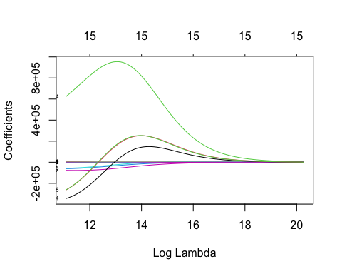
cat("\n --- Ridge Coefficients --- \n")
##
## --- Ridge Coefficients ---
beta_M <- coef(ridge_fit_M, s = lambda_min)[-2] #Take beta coefficients corresponding to the lambda min value
#excluding the second entry
STEP 18: RIDGE REGRESSION BOOTSTRAPPING Results from Ridge Regression only show that property-size is significant, which futher confirms that Property size is the best predictor for price of houses in the UK.
set.seed(321)
#Code taken from lecture notes Topic 21 Ridge Regression
B <- 1000
p_M <- ncol(X_W)
boot_b_M <- matrix(NA_real_, nrow = B, ncol = p_M)
colnames(boot_b_M) <- colnames(X_W)
n <- nrow(X_W)
for (b in 1:B) {
idx <- sample.int(n, size = n, replace = TRUE)
fit_b <- glmnet(X_W[idx, ], df_clean$price[idx], alpha = 0,
lambda = lambda_min_M, standardize = FALSE)
boot_b_M[b, ] <- as.numeric(coef(fit_b))[-2]
}
ci_coef_M <- t(apply(boot_b_M, 2, quantile, probs = c(0.025, 0.975)))
#Table with bootstrapped confidence interval
ridge_tab_M <- data.frame(
Term = colnames(boot_b_M),
Beta_hat = beta_M,
CI2.5 = ci_coef_M[, 1],
CI97.5 = ci_coef_M[,2],
row.names = NULL
)
cat("\n --- Ridge Regression Table --- \n"); ridge_tab_M
##
## --- Ridge Regression Table ---
## Term Beta_hat CI2.5
## 1 (Intercept) 860194.80442 -790.09203015
## 2 property_size_sqft 90.52156 399.73466030
## 3 satisfaction_score -3284.90036 -8.76561985
## 4 emi_to_income_ratio 682927.78768 -12.88111106
## 5 factor(city)Liverpool -10550.43852 -10.15073648
## 6 factor(city)London -1296.58172 -12.08742171
## 7 factor(city)Manchester -25369.13536 -30.68948009
## 8 property_size_sqft:factor(city)Liverpool 19.34572 -0.08331168
## 9 property_size_sqft:factor(city)London 19.19797 -0.37350344
## 10 property_size_sqft:factor(city)Manchester 20.13500 -0.05608389
## 11 satisfaction_score:factor(city)Liverpool -2399.52498 -111.28341505
## 12 satisfaction_score:factor(city)London -1958.75104 -95.92670564
## 13 satisfaction_score:factor(city)Manchester -2767.86829 -74.68222016
## 14 emi_to_income_ratio:factor(city)Liverpool 147202.71141 -5.67104648
## 15 emi_to_income_ratio:factor(city)London 236629.46240 -6.51978535
## 16 emi_to_income_ratio:factor(city)Manchester 235008.92909 -6.94622836
## CI97.5
## 1 1001.4050056
## 2 400.1370938
## 3 156.2471491
## 4 2.9281349
## 5 19.3213859
## 6 17.8482959
## 7 2.5930074
## 8 0.3825810
## 9 0.0736750
## 10 0.3576139
## 11 42.0207228
## 12 70.1673733
## 13 61.6654284
## 14 2.7454434
## 15 0.6812285
## 16 1.3301569
STEP 19: TEST HYPOTHESIS Our final step was running an anova test to truly test our hypothesis using a weighted full model and a weighed model without city interactions as our reduced model. Since our p value is less than 0.05 we can reject the null and can conclude that at least one predictor is significant when also considering city. This makes sense espeically in comparison to the location characteritics model because property size is the best indicator for predicting price intuitively (and through what has been shown here), so becuae it already has a significant effect it would probably be more sensitive to minor changes in the city unlike something that wouldn’t predict price well.
#Any overall regional effects on the chosen predictors
full_Model <- lm(price ~ property_size_sqft + satisfaction_score + emi_to_income_ratio +
property_size_sqft*factor(city) + satisfaction_score*factor(city) +
emi_to_income_ratio*factor(city), data = df_clean, weights = Weights)
reduced_Model <- lm(price ~ property_size_sqft + satisfaction_score + emi_to_income_ratio,
data = df_clean, weights = Weights)
anova(reduced_Model, full_Model)
## Analysis of Variance Table
##
## Model 1: price ~ property_size_sqft + satisfaction_score + emi_to_income_ratio
## Model 2: price ~ property_size_sqft + satisfaction_score + emi_to_income_ratio +
## property_size_sqft * factor(city) + satisfaction_score *
## factor(city) + emi_to_income_ratio * factor(city)
## Res.Df RSS Df Sum of Sq F Pr(>F)
## 1 320 0.0071650
## 2 308 0.0065404 12 0.0006246 2.4511 0.004603 **
## ---
## Signif. codes: 0 '***' 0.001 '**' 0.01 '*' 0.05 '.' 0.1 ' ' 1

